File group.properties

File user.properties

File login.config

Code

Person

XML Convert

Sender

Receive

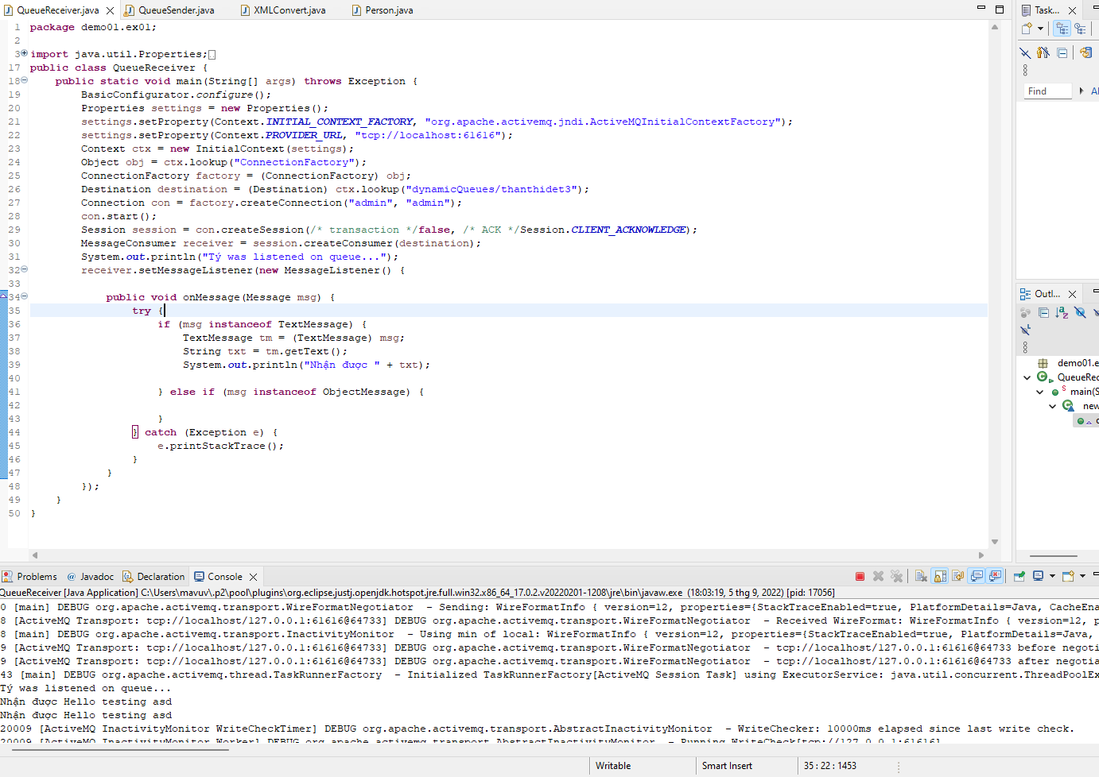

ActiveMQ Queue

